S. Rushi Keshava Reddy
192472355
CSA 6503 - Generative Ai
CO4 – AT1
31. Multilingual Translation Application – Develop an application that accepts text in English and translates it into at least two different target languages. Provide a language-selection option in the interface.

Project Requirements
- Accept text in English
- Translate it into at least two languages
- Provide a language selection option
- Display the translated text
Example Languages
- Telugu
- Hindi
- Tamil
Simple Interface Design
- Input Text Box → Enter English text
- Language Dropdown → Select Hindi / Telugu / Tamil
- Translate Button → Translate the text
- Output Box → Show translated text
Python Code
First install the required library:
pip install deep-translator
Then create app.py:
import tkinter as tk
from tkinter import ttk, messagebox
from deep_translator import GoogleTranslator

def translate_text():
text = input_box.get("1.0", tk.END).strip()
language = language_combo.get()

if text == "":
messagebox.showwarning("Warning", "Please enter English text")
return

languages = {
"Hindi": "hi",
"Telugu": "te",
"Tamil": "ta"
}

try:
translated = GoogleTranslator(
source="en",
target=languages[language]
).translate(text)

output_box.delete("1.0", tk.END)
output_box.insert(tk.END, translated)

except Exception as e:
messagebox.showerror("Error", str(e))

root = tk.Tk()
root.title("Multilingual Translation Application")
root.geometry("600x450")

tk.Label(
root,
text="Multilingual Translation Application",
font=("Arial", 16, "bold")
).pack(pady=10)

tk.Label(root, text="Enter English Text:").pack()

input_box = tk.Text(root, height=6, width=60)
input_box.pack(pady=5)

tk.Label(root, text="Select Target Language:").pack()

language_combo = ttk.Combobox(
root,
values=["Hindi", "Telugu", "Tamil"],
state="readonly"
)
language_combo.pack(pady=5)
language_combo.set("Hindi")

tk.Button(
root,
text="Translate",
command=translate_text
).pack(pady=10)

tk.Label(root, text="Translated Text:").pack()

output_box = tk.Text(root, height=6, width=60)
output_box.pack(pady=5)

root.mainloop()
Example
Input:
Hello, how are you?
Hindi:
नमस्ते, आप कैसे हैं?
Telugu:
హలో, మీరు ఎలా ఉన్నారు?
Tamil:
வணக்கம், நீங்கள் எப்படி இருக்கிறீர்கள்?
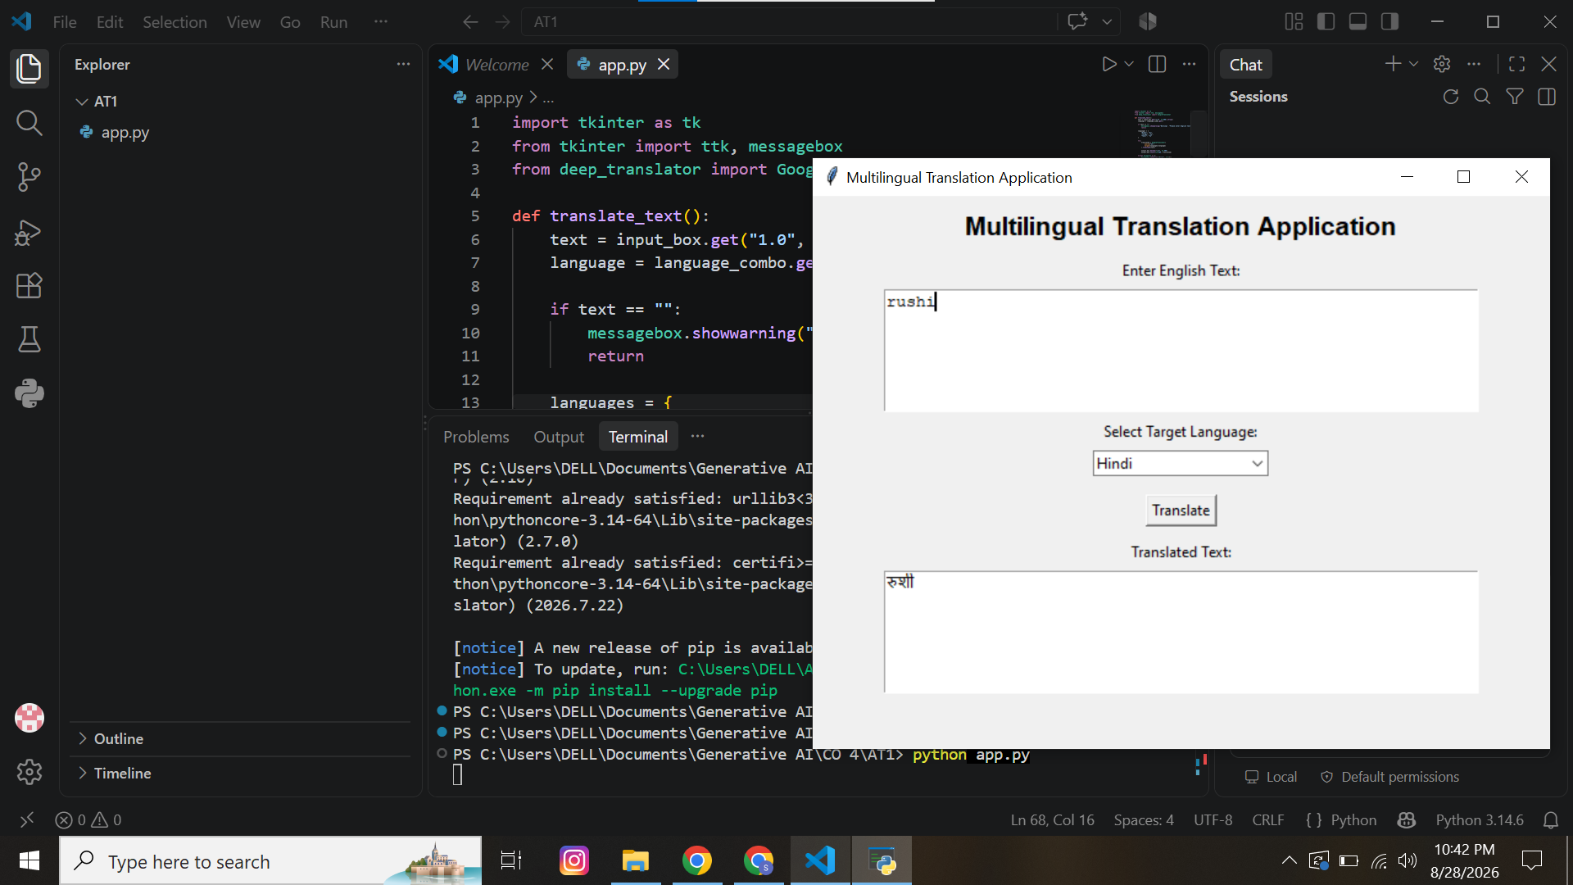
Output: A simple GUI application where the user enters English text, selects a language, and gets the translation.

